**COMMUNITY SERVICE PROJECT**

**ON**

**REAL TIME WATER LEVEL DETECTION AND ALERTING**

*A project report submitted in the partial fulfillment of*

*Requirements for the award of the Degree of*

**BACHELOR OF TECHNOLOGY**

**IN**

**COMPUTER SCIENCE AND ENGINEERING**

Name of the Student : DEVANABOINA RENUKA VENKATA PADMA

Registration Number : **22501A0540**

Year of Study : 2ND YEAR ,CSE

Name of the College : PRASAD V POTLURI SIDDHARTHA INSTITUTE OF

TECHNOLOGY

Period of CSP : **6 weeks** From: 24/07/2023 To: 02/09/2023

**Under the Guidance of**

**Mr. A .Prashant B.E.,M.Tech.,(Ph.D)**

Assistant Professor



**Department of Computer Science and Engineering**

**PRASAD V POTLURI SIDDHARTHA INSTITUTE OF TECHNOLOGY**

(AUTONOMOUS) (Affiliated to JNTU: Kakinada, Approved by AICTE)

(An ISO Certified Institution and NBA, NAAC-A+ Accredited)

**Kanuru, Vijayawada – 520007**

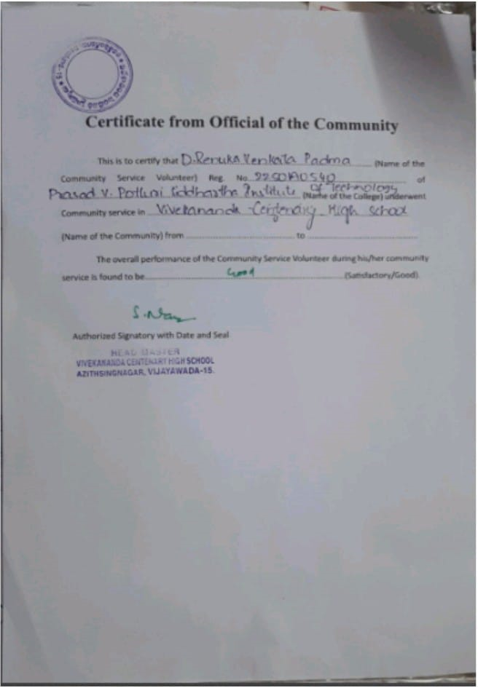

**PRASAD V POTLURI**

SIDDHARTHA INSTITUTE OF TECHNOLOGY

(Affiliated to JNTU: Kakinada, Approved by AICTE)

(An ISO certified and NBA accredited institution)

**Kanuru , Vijayawada – 520007**



**CERTIFICATE**

This is to certify that the community service project entitled “**REAL TIME WATER LEVEL DETECTION AND REPORTING**” is submitted by “D .RENUKA VENKATA PADMA (22501A0540)”, II B.Tech Ist Semester in partial fulfillment of the requirement for the award of **BACHELOR OF TECHNOLOGY** in **COMPUTER SCIENCE AND ENGINEERING** From 24.Jul.2023 To 02.Sep.2023 (6 Weeks) in the academic year 2023-2024.

**Signature of the Guide Signature of the HOD**

**Mr.A.Prashant Dr.A . Jayalakshmi**

**B.E.,M.Tech.,(Ph.D)**  **B.Tech, M.S, M.Tech,Ph**  **B.Tech, M.S, M.Tech,Ph.D**.,

Student’s Declaration

I,D.RENUKA ,**I** AM student of B.Tech Program, Reg. No. 22501A0540 of the Department of Computer Science and Engineering, Prasad V. Potluri Siddhartha Institute of Technology do hereby decl,are that I have completed the mandatory community service from 24.Jul. 2023 to 02. Sep. 2023 in Vivekananda Centenary High School under the guidance of Mr. A. Prashant, Assistant Professor ,Department of Computer Science and Engineering, PVPSIT.

***(Signature and Date)***

**Acknowledgement**

I would like to thank the **Government of Andhra Pradesh** and **JNTUK Kakinada** for their support and initiation of community service project.

I would like to thank the **HEAD MASTER OF THE SCHOOL** for providing a great support for us in completing my community service project.

I would like to take this opportunity to thank our beloved Principal,

**Dr. K. Sivaji Babu**, for providing a great support for us in completing my project and for giving us the opportunity of doing the project.

At the same time, we feel elated to thank our Professor and Head of the Department,

**Dr. A. Jayalakshmi**, and for inspiring us all the way and arranging all the facilities and resources needed for the project.

It is with the immense pleasure that I would like to express our indebted gratitude to our guide **Mr.A.Prashant**, Computer Science & Engineering, who has guided us a lot and encouraged us in every step of the project work. His support throughout the project helped us to complete the project within the time.

I am very much grateful to all the staff and faculty of Department of CSE for their cooperation during the course of this project work. Finally, I would like to express our sincere thanks to each and every one of our college, who have contributed their help and guidance for the successful completion of this project.

**Project Associate**

**D.Renuka**

**22501A0540**

|  |  |
| --- | --- |
| **CONTENTS** | **Page No.** |
| Certificate From Official of the Community | 2 |
| Certificate | 3 |
| Student’s Declaration | 4 |
| Acknowledgement | 5 |
| List of Figures | 6 |
|  |  |
| Chapter 1 Executive Summary | 8 |
| Chapter 2 Overview of the Community | 10 |
| Chapter 3 Community Service Part | 13 |
| Chapter 4 Activity Log |  |
| 4.1 Activity Log of First Week | 14 |
| 4.1.1 Detailed Weekly Report | 15 |
| 4.2 Activity Log of Second Week | 16 |
| 4.2.1 Detailed Weekly Report | 17 |
| 4.3 Activity Log of Third Week | 18 |
| 4.3.1 Detailed Weekly Report | 19 |
| 4.4 Activity Log of Fourth Week | 20 |
| 4.4.1 Detailed Weekly Report | 21 |
| 4.5 Activity Log of Fifth Week | 22 |
| 4.5.1 Detailed Weekly Report | 23 |
| 4.6 Activity Log of Sixth Week | 24 |
| 4.6.1 Detailed Weekly Report | 25 |
| Chapter 5: Outcomes Description | 26 |
| Report of the Mini-Project Work Done in the Related Subject w.r.t the Habitation/Village | 28 |
| Chapter 6: Recommendation and Conclusion | 40 |
|  |  |

|  |  |
| --- | --- |
| **LIST OF FIGURES** | **Page No.** |
| Government High School. | 10 |
| Government High School. | 11 |
| Hospitals and Playground | 12 |
|  |  |

CHAPTER 1: EXECUTIVE SUMMARY

I selected Vivekananda Centenary High School, which is a locality in Vijayawada City in Andhra Pradesh State, India. It belongs to Andhra Region. It has around 1200 students and 50 teachers. Vivekananda Centenary High School was established in 1964 and it is managed by the Local body. It is in Rural area. It is in AZITSING NAGAR, VIJAYAWADA - 15 of KRISHNA district of ANDHRA PRADESH. The school consists of Grades from 1to 10. The school is Co-educational, and it also have an attached pre-primary section.

As per the Municipal Administration and Urban Development Department this school provides good infrastructure, Skill laboratories, Purified drinking water, Kitchen where the lunch for students is prepared, playground and Nondigital Library to the students. This school promotes creativity and innovation in student learning and make them to create new things.

Some of the facilities that can be concentrated are:

• Innovation Laboratory.

• Student-Centric Approach

• Playground.

• Holistic Education

• Cultural and Sports Activities

I visited this school and collected information about the functioning, teaching, problems they are facing, schemes that are going on, available facilities, administration and interacted with students about their opinions on the school. In the vibrant classrooms of VIVEKANANDA CENTENARY HIGH SCHOOL in Ajith Singh Nagar, Vijayawada, socially conscious students gathered to discuss their pressing issues affecting their community. Engaged in a spirited conversation, the students explored various societal problems, recognizing the need for collective action. As their dialogue unfolded, the focus shifted to a critical issue that often plagues their region - the recurrent flooding of low-lying areas during times of heavy rainfall.

I sought to understand the challenges faced by the students. During my interactions, I discovered a recurring concern among them—the flooding of low-lying areas during periods of intense rainfall. Approaching this matter with empathy, I engaged in open conversations with the students to delve deeper into the issue.

After gathering the information from the students for their concern towards the low lying area people who are facing a lot of consequences during the heavy rainfalls which results rise in the water levels in the river,so our team decided to create an “REAL IME WATER DETECTION AND ALERTING” that can help all the citizens living in that particular area. For this Project I learned the application of technologies like Internet of things, Arduino Uno, temperature sensor and etc. This project helped me in learning new technologies and helped me in developing knowledge.

CHAPTER 2: OVERVIEW OF THE COMMUNITY

Ajith Singh Nagar is a locality of Vijayawada in Krishna District of the Indian State of Andhra Pradesh. The colony was named after Ajit Singh, a freedom fighter and a close associate of Mahatma Gandhi. The colony has some notable landmarks, such as the indoor and outdoor municipal corporation stadium, the biggest park in the city, and the second flyover in the city. The park is being set up in 10 acres at a cost of Rs 10 crore.

Vivekananda Centenary High School was established in 1964. It is located in Rural area of Andhra Pradesh state of India. Area pin code is 520015.School is providing Pre- Primary, Primary (1-5), Secondary (6-10) level education and is being managed by Local body. It is the Medium of instruction is Telugu, English language and school is Co-educational School is affiliated with State Board for secondary level.

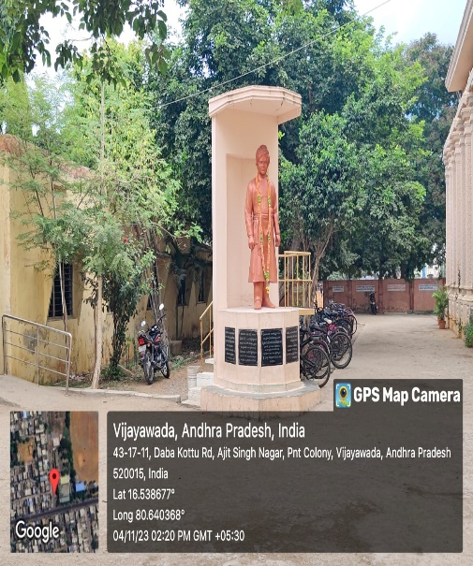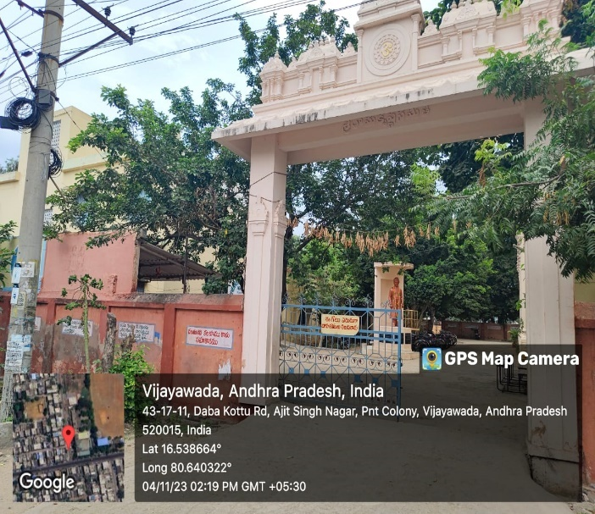

VIVEKANANDA CENTENARY HIGH SCHOOL, AJITH SIGH NAGAR

School has an appropriate building. All the classrooms of the school are in good condition. It has 2 other rooms for non-teaching activities. School has separate room for Headmaster/Teacher. The school has electric connection and drinking water facilities. The school has a playground. The school has a library which consists of number of books that helps the students to gain the knowledge. School also consists of a Chemistry and Biology laboratories. The school is applicable for providing mid-day meal.

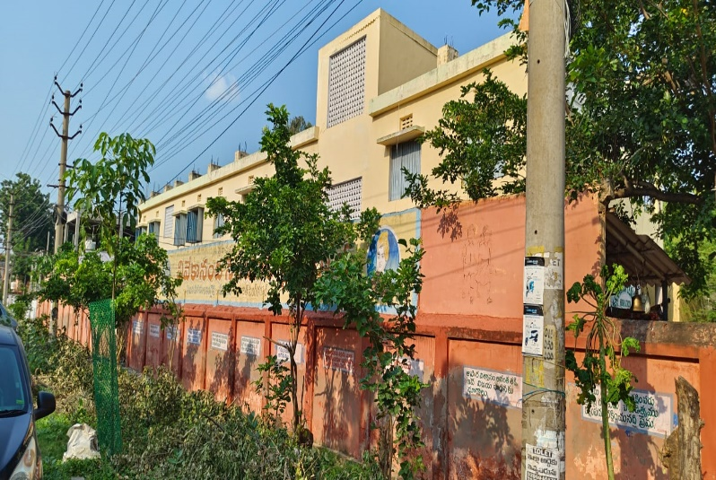 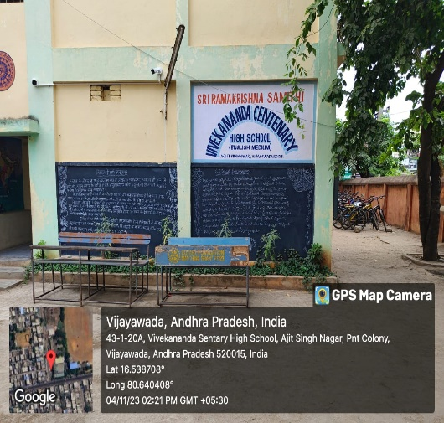

VIVEKANANDA CENTENARY HIGH SCHOOL

Some of the concentrated places for people welfare are hospitals and playground. In Ajith Singh Nagar in Vijayawada is a colony that has some of the best hospitals in the city. These hospitals provide various services for the people, such as gynecology, obstetrics, orthopedics, pulmonology, and more. best hospitals in Ajith Singh Nagar that provide services for the people. They have good doctors, staff, facilities, and equipment to cater to the needs of the patients. They also have a good feedback from the patients who have visited them.

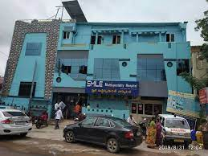 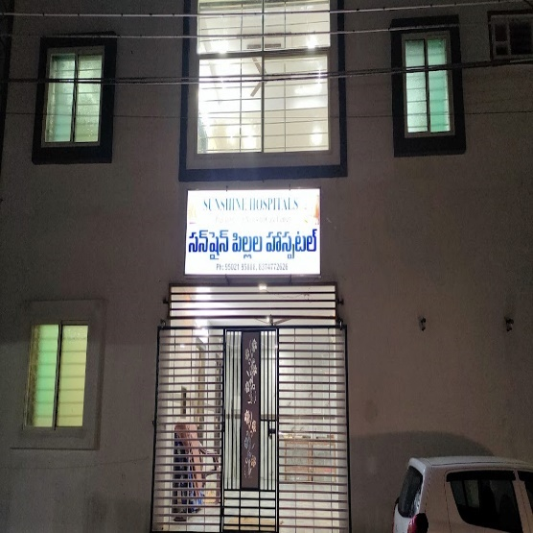

HOSPITALS IN AJITH SINGH NAGAR

Ajith Singh Nagar in Vijayawada is a colony that has a large playground and a municipal corporation stadium. The playground is part of the Makineni Basava Punnaiah Stadium, which is named after a communist leader and freedom fighter. The stadium is used for various sports and games, such as cricket, football, hockey, volleyball, and badminton. The stadium also has an indoor stadium, a gym, and a park. The stadium is open for all and hosts many tournaments and events. The Vijayawada Municipal Corporation (VMC) is responsible for the development and maintenance of the playground and the stadium. The VMC has also launched an Information Park on the site of a former 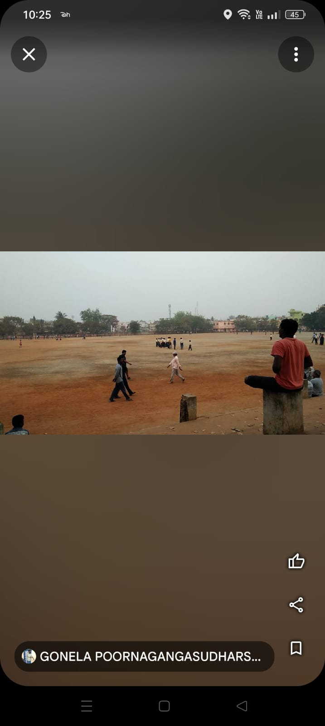dumping ground, through innovative bioremediation techniques.

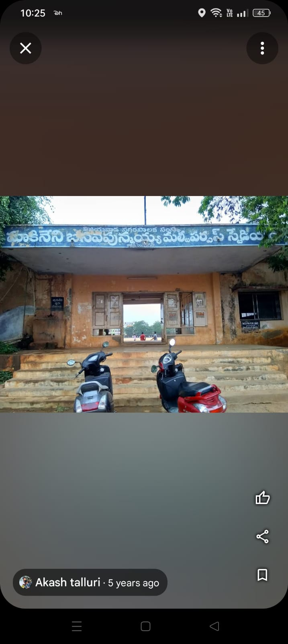

The Makineni Basava Punnaiah Stadium, Ajith Singh Nagar

CHAPTER 3 : COMMUNITY SERVICE PART

I visited the Vivekananda Centenary High School -Ajith Singh Nagar and gathered information besides interacting with the students and management of the school. They explored various societal problems, recognizing the need for collective action. As their dialogue unfolded, the focus shifted to a critical issue that often plagues their region - the recurrent flooding of low-lying areas during times of heavy rainfall

Interaction with the students, teaching staff and school management all discussed about the societal issues.

The teaching faculty of Vivekananda Centenary High School, Ajith Singh Nagar felt very happy to share their experiences about the school and their students. The school management was also interested to explore new things for students and to enhance the technical knowledge of their school students. The school management was also interested in teaching the advanced technologies to their students.

I also interacted with the students in the school who are very enthusiastic about learning new things and exploring new technologies. The students have well qualified faculty to improve their knowledge over many aspects.

The life skills learnt by this activity is to improve my communication skills while explaining the project to students and management of school in detail I developed my problem solving skills and leadership qualities. During this activity main aim is to build social skills and technical skills in the students.

I visited the school and observed the various standard of studying students. I also collected the information regarding some of the issues in the schools.

So, I created a REAL TIME WATER LEVEL DETECTION AND ALERTING

Using IOT , BOLT -IOT WIFI MODULE , PROGRAMMING CODE, ARDUINO UNO and included BUZZER that serve as a great help for the people nearby to understand that the water level is increased.

CHAPTER 4: ACTIVITY LOG

4.1 ACTIVITY LOG FOR THE FIRST WEEK

|  |  |  |  |
| --- | --- | --- | --- |
| **Day & Date** | **Brief description of the daily**  **activity** | **Learning**  **Outcome** | **Person In- Charge Signature** |
| Day – 1  24.07.2023 | Selection of historical profile of the habitation | Identifying the facilities. |  |
| Day – 2  25.07.2023 | Selection of historical profile of the habitation | Identifying the facilities |  |
| Day – 3  26.07.2023 | Identification of the problem(s) | Observation in the way of attendance taking. |  |
| Day – 4  27.07.2023 | Data collection and statistics related to habitation | Knowing the system of the school. |  |
| Day – 5  28.07.2023 | Solution to the problem | Identifying important information. |  |
| Day –6  29.07.2023 | Scope and significance of the work | Identifying important information |  |

WEEKLY REPORT

WEEK – 1 (from 24/07/2023 to 29/07/2023)

|  |
| --- |
| **Objective of the Activity Done: Problem identification and solution** |
| **Detailed Report:** Vivekananda Centenary High School -Ajith Singh Nagar is a government school in Vijayawada City in Andhra Pradesh State, India. It has around 1200 students and 50 teachers. They provide different facilities like Library , Purified Drinking Water, Hygiene food, Playground , Labs etc. The way of teaching in this school is prefect to learn new things and they make the students learn from the world. The way of teaching lessons to students is adorable . socially conscious students gathered to discuss their pressing issues affecting their community. Engaged in a spirited conversation, the students explored various societal problems, recognizing the need for collective action. As their dialogue unfolded, the focus shifted to a critical issue that often plagues their region - the recurrent flooding of low-lying areas during times of heavy rainfall.  From the Discussion I decided to take up a project on detection of water level in rivers and also about the temperature and humidity checking and come into conclusion that that all these parameters together will be suitable to real time water level detection and reporting during the time of heavy rainfall and during the time of Floods.  I selected the place Krishna Lanka as the habitation to collect the information regarding the problems they safe at the time of floods and heavy rainfall. After collecting the information I got to know that people who are living near the Krishna river safe terrible issues in the time of heavy rainfall and floods. During heavy rainfalls and floods the houses near the river bank are submerged with water. This results in the loss of habitation foe the local people who live that areas. Some people also lost their lives , lost their Farms and some people lost their animals. Now I decided to do a project on real time water level detection and alerting system. |

4.2 ACTIVITY LOG FOR THE SECOND WEEK

|  |  |  |  |
| --- | --- | --- | --- |
| **Day & Date** | **Brief description of the daily**  **activity** | **Learning**  **Outcome** | **Person In- Charge Signature** |
| Day – 1  31.07.2023 | Identification of different requirements. | Observation and analyzation skills |  |
| Day – 2  01.08.2023 | Identification of different requirements. | Observation and analyzation skills |  |
| Day – 3  02.08.2023 | Specifications of Hardware/Software requirements | Observation and analyzation skills |  |
| Day – 4  03.08.2023 | Specifications of Hardware/Software requirements | Observation and analyzation skills |  |
| Day – 5  04.08.2023 | Specifications of Functional/ Non-functional requirements | Observation and analyzation skills |  |
| Day –6  05.08.2023 | Specifications of Functional/ Non-functional requirements | Observation and analyzation skills |  |

WEEKLY REPORT

WEEK – 2 (from 31/07/2023 to 05/08/2023)

|  |
| --- |
| **Objective of the Activity Done: Gathering of requirements** |
| **Detailed Report**: Arduino uno serves as the main microcontroller to read data from sensors, process information, and control the output devices. It interfaces with both the sensors and the Bolt-IoT module. Bolt IoT wifi module connects the system to the internet and the Bolt-IoT Cloud platform for data transmission, alerting, and monitoring. Breadboard provides a platform for connecting and prototyping the electronic components in a neat and organized manner. Visual indicators for water level alerts. Green LED Indicates normal water levels. Red LED Indicates high water levels or flooding. White LED can be used for a warning or intermediate alert level. LCD Display displays real-time information such as temperature, water level, and alert messages for local monitoring. HC-SR04 ultrasonic sensor measures the distance to the water surface and determines the water level. Ultrasonic pulses are emitted, and the time taken for the echo to return is used to calculate the distance. LM -35 Temperature sensor measures the ambient temperature. Although not directly related to water level, temperature data can be useful for environmental monitoring. |

**4.3 ACTIVITY LOG FOR THE THIRD WEEK**

|  |  |  |  |
| --- | --- | --- | --- |
| **Day & Date** | **Brief description of the daily**  **activity** | **Learning**  **Outcome** | **Person In- Charge Signature** |
| Day – 1  07.08.2023 | System design/architecture/framework | Circuit Designing |  |
| Day – 2  08.08.2023 | Design of Hardware/Software modules | Circuit Designing and Programming |  |
| Day – 3  09.08.2023 | Design of Hardware/Software modules | Circuit Designing and Programming |  |
| Day – 4  10.08.2023 | Design of Hardware/Software modules | Circuit Designing and Programming |  |
| Day – 5  11.08.2023 | Methodology (detailed description of the working of the project) | Reporting the information |  |
| Day –6  12.08.2023 | Methodology (detailed description of the working of the project) | Reporting the information |  |

**WEEKLY REPORT**

**WEEK – 3 (from 07/08/2023 to 12/08/2023)**

|  |
| --- |
| **Objective of the Activity Done: System Design** |
| **Detailed Report:**  Initialization: Connect the Arduino, sensors, LEDs, buzzer, LCD, and Bolt-IoT module on the breadboard. Power the system using the 9V battery or USB cable.  Sensor Reading: The LM35 temperature sensor and HC-SR04 ultrasonic sensor continuously read temperature and water level data, respectively.  Data Processing: The Arduino processes the sensor data and determines if the water level is within the acceptable range.  Alerting: Based on the water level, the Arduino activates the appropriate LEDs and the buzzer to provide visual and audible alerts.  Local Display: The LCD display shows real-time information, including temperature, water level, and alerts for local monitoring.  Data Transmission: The Arduino sends the sensor data, alerts, and status information to the Bolt-IoT module.  Cloud Interaction: The Bolt-IoT module transmits data to the Bolt-IoT Cloud platform, enabling remote monitoring and alerting.  Alert Notification: The Bolt-IoT Cloud platform triggers alerts (emails, SMS) based on the received data.  Continuous Monitoring: The system continuously monitors temperature and water level, providing real-time information and alerts as needed. |

**4.4 ACTIVITY LOG FOR THE FOURTH WEEK**

|  |  |  |  |
| --- | --- | --- | --- |
| **Day & Date** | **Brief description of the daily**  **activity** | **Learning**  **Outcome** | **Person In- Charge Signature** |
| Day – 1  14.08.2023 | Implementation of hardware/ software | Technical Skills |  |
| Day – 2  15.08.2023 | Implementation of hardware/ software | Technical Skills |  |
| Day – 3  16.08.2023 | Implementation of hardware/ software | Technical Skills |  |
| Day – 4  17.08.2023 | Implementation of hardware/ software | Technical Skills |  |
| Day – 5  18.08.2023 | Implementation of hardware/ software | Technical Skills |  |
| Day –6  19.08.2023 | Implementation of hardware/ software | Technical Skills |  |

**WEEKLY REPORT**

**WEEK – 4 (from 14/08/2023 to 19/08/2023)**

|  |
| --- |
| **Objective of the Activity Done: System Implementation** |
| **Detailed Report:** The implementation of a water level rise detection and reporting system using components like the Bolt-IoT wifi module, Arduino Uno, sensors, and indicators proves immensely valuable for society. This system acts as a proactive measure against potential floods, offering early warnings and promoting disaster preparedness. The integration with the Bolt-IoT Cloud platform allows for real-time monitoring remotely, enabling swift and informed decision-making by emergency response teams. Its affordability and accessibility make it suitable for various communities, contributing to the democratization of advanced technologies. Beyond its technical functionalities, the system empowers communities with actionable data, fostering resilience and a sense of security. By offering educational opportunities, especially if implemented in schools, the project cultivates awareness about environmental monitoring and disaster resilience. Overall, the water level rise detection system emerges as a cost-effective, community-driven solution that enhances public safety, reduces risks, and contributes to the overall well-being of society. |

**4.5 ACTIVITY LOG FOR THE FIFTH WEEK**

|  |  |  |  |
| --- | --- | --- | --- |
| **Day & Date** | **Brief description of the daily**  **activity** | **Learning**  **Outcome** | **Person In- Charge Signature** |
| Day – 1  21.08.2023 | Testing and validation of project results/reports | Identifying errors and adding corrections |  |
| Day – 2  22.08.2023 | Testing and validation of project results/reports | Identifying errors and adding corrections |  |
| Day – 3  23.08.2023 | Testing and validation of project results/reports | Identifying errors and adding corrections |  |
| Day – 4  24.08.2023 | Testing and validation of project results/reports | Identifying errors and adding corrections |  |
| Day – 5  25.08.2023 | Testing and validation of project results/reports | Identifying errors and adding corrections |  |
| Day –6  26.08.2023 | Testing and validation of project results/reports | Identifying errors and adding corrections |  |

**WEEKLY REPORT**

**WEEK – 5 (from 21/08/2023 to 26/08/2023)**

|  |
| --- |
| **Objective of the Activity Done: Results testing and validation** |
| **Detailed Report :** Module testing is one of important phase in this project. The main objective on running this testing is to ensure that all the module are in good condition and working as expected. Testing the modules in the water level rise detection and reporting system is a critical phase to ensure the correct functionality and reliability of the entire setup. The initial step involves a thorough examination of the hardware connections, ensuring that all components are properly connected to the Arduino and the Bolt-IoT WiFi module. Subsequently, individual modules are tested systematically. The LM35 temperature sensor's accuracy is verified by comparing its readings with a calibrated thermometer. The HC-SR04 ultrasonic sensor is tested by placing it at various distances from a flat surface and confirming accurate distance measurements. LEDs and the buzzer are assessed by activating them manually and confirming their responsiveness. The 16x2 LCD display is tested for proper initialization and the correct display of data. The Bolt-IoT WiFi module is examined for its ability to connect to the Wi-Fi network and transmit data to the Bolt-IoT Cloud platform. Additionally, the entire system undergoes simulated testing in controlled environments to mimic water level changes, ensuring that the alert mechanisms, both local (LEDs and buzzer) and remote (cloud notifications), function as intended. This comprehensive testing process ensures the robustness of each module and the seamless integration of the entire water level detection system. If incorrect connections are made in the water level rise detection and reporting system, several issues may arise, affecting the overall functionality and reliability of the project. Incorrect connections can lead to miscommunication between modules, inaccurate sensor readings, and failure of output devices. |

**4.6 ACTIVITY LOG FOR THE SIXTH WEEK**

|  |  |  |  |
| --- | --- | --- | --- |
| **Day & Date** | **Brief description of the daily**  **activity** | **Learning**  **Outcome** | **Person In- Charge Signature** |
| Day – 1  28.08.2023 | Preparation of the project report | Organization and Presentation |  |
| Day – 2  29.08.2023 | Preparation of the project report | Organization and Presentation |  |
| Day – 3  30.08.2023 | Preparation of the project report | Organization and Presentation |  |
| Day – 4  31.08.2023 | Preparation of the project report | Organization and Presentation |  |
| Day – 5  01.09.2023 | Preparation of the project report | Organization and Presentation |  |
| Day –6  02.09.2023 | Preparation of the project report | Organization and Presentation |  |

**WEEKLY REPORT**

**WEEK – 6 (from 28/08/2023 to 02/09/2023)**

|  |
| --- |
| **Objective of the Activity Done: Document preparation** |
| **Detailed Report**: After listening to the students concern towards the people who are living in low-lying area i.e near Krishna river . The people are facing many issues during heavy rainfall and floods. We reached that particular place and we conducted the survey for the local residents . All information gathered from citizens living near river bank ,students and teachers in the school and from observations and surveys are documented in the report and details about the mini project “Real Time Water level detection and reporting“ is reported and the activities and programs done, and weekly reports are documented . |

**CHAPTER 5**

**OUTCOMES DESCRIPTION**

Details of the Socio-Economic Survey of the Village/Habitation Attach the questionnaire prepared for the survey.

Q. Are you aware of the potential risks and challenges associated with living in a low-lying area near the riverbank, especially during heavy rainfall and floods?

Q. Have you received information or guidance on flood preparedness and evacuation procedures?

Q. Have you personally experienced flooding in your area during heavy rainfall in the past?

Q. Can you share any specific challenges or issues you faced during previous flood events?

Q. Are there effective communication channels in place for disseminating timely information during flood events?

Q. How do you typically receive information about weather forecasts and flood alerts in your area?

Q. Are there community initiatives or organizations that actively engage in flood resilience activities?

Q. What suggestions do you have for implementing an effective early warning system that can provide residents with timely information about potential heavy rainfall and flood events?

**Describe the problems you have identified in the community.**

When I visited Vivekananda Centenary High School, Ajith Singh Nagar socially conscious students gathered to discuss their pressing issues affecting their community. Engaged in a spirited conversation, the students explored various societal problems, recognizing the need for collective action. As their dialogue unfolded, the focus shifted to a critical issue that often plagues their region - the recurrent flooding of low-lying areas during times of heavy rainfall.

After listening to the students concern towards the people who are living in low-lying area i.e near Krishna river. I selected the place Krishna Lanka as the habitation to collect the information regarding the problems they safe at the time of floods and heavy rainfall. After collecting the information I got to know that people who are living near the Krishna river safe terrible issues in the time of heavy rainfall and floods.

During heavy rainfalls and floods the houses near the river bank are submerged with water. This results in the loss of habitation foe the local people who live that areas. Some people also lost their lives , lost their Farms and some people lost their animals.

**Short-term and long-term action plan for possible solutions for the problems identified and that could be recommended to the concerned authorities for implementation.**

SHORT TERM ACTION PLAN:

In the immediate action of heavy rainfall and floods affecting residents in low-lying areas near the riverbank, a short-term action plan is essential for prompt response and relief. Emergency response training sessions will be conducted to empower residents with necessary skills, and temporary shelters equipped with essential supplies will be established. Relief packages addressing immediate needs, rapid response teams for livestock and pet rescue, medical camps, and public awareness campaign.

LONG TERM ACTION:

A pivotal component of the long-term flood resilience strategy involves the development and implementation of an IoT-based project model for early flood detection and reporting. This forward-looking initiative aims to leverage cutting-edge technology to enhance the community's preparedness and response mechanisms. The project model envisions the deployment of IoT sensors strategically placed in flood-prone areas, continuously monitoring water levels and weather conditions. These sensors will be integrated with a central hub, which can transmit real-time data to a cloud-based platform for analysis.

**Report of the mini-project work done in the related subject w.r.t the habitation/village.**

A mini-project work in the related subject w.r.t the habitation/village. (For ex., a student of Botany may do a project on Organic Farming or Horticulture or usage of biofertilizers or biopesticides or effect of the inorganic pesticides, etc. A student of Zoology may do a project on Aquaculture practices or animal husbandry or poultry or health and hygiene or Blood group analysis or survey on the Hypertension or survey on the prevalence of diabetes, etc**.**

**The Report shall be limited to 8-10 pages.**

An IoT Real Time water level detection and reporting in which we will monitor the water level in the river and also the temperature and humidity. LED lights indicates level of the water .

If there is a rise in water level it will make an alert by using buzzer sound and turning on the red light.

Bolt IT WiFi module connects the system to the internet and the Bolt-IoT Cloud platform for data transmission, alerting, and monitoring.

Arduino serves as the main microcontroller to read data from sensors, process information, and control the output devices. It interfaces with both the sensors and the Bolt-IoT module.

Integrate the 5mm LEDs (Green, Red, Orange) and buzzer into the system, connecting them to the Arduino Uno for alert mechanisms. Attach the 16×2 LCD display to the setup, allowing for real-time information display.

Incorporate the LM35 Temperature Sensor and HC-SR04 Ultrasonic Sensor into the system to monitor temperature and water levels respectively. Ensure proper connections of these sensors to the Arduino Uno for accurate data acquisition. Utilize a combination of male to female, male to male, and female to female jumper wires as needed to establish secure connections among the components. Integrate a 9V battery with a snap connector to power the system and guarantee its functionality in case of a power outage. Lastly, connect the system to a computer using a USB cable Type B to load.

Arduino IDE is used for writing the program.

CONNECTIONS:

1)VCC of  Green, white ,red Colour LED to Digital Pin ‘10’ , ‘11’ , ‘12’ of

the Arduino.

GND of Green, white , red Colour LED to the GND of Arduino.

2)VCC of  Buzzer to Digital Pin ‘13’ of the Arduino.

GND of Buzzer to the GND of Arduino.

3)VCC of Ultrasonic Sensor to 5v of Arduino.

GND of Ultrasonic Sensor to GND of Arduino.

Echo of Ultrasonic Sensor to Digital Pin ‘8’ of Arduino.

Trig of Ultrasonic Sensor to Digital Pin ‘9’ of Arduino.

4)5v of Bolt WiFi Module to 5v of Arduino.

GND of Bolt WiFi Module to GND of Arduino.

TX of Bolt WiFi Module to RX of Arduino.

RX of Bolt WiFi Module to TX of Arduino.

5) VCC of LM35 to 5v of Bolt WiFi Module.

Output Pin of LM35 to Pin ‘A0’ of Bolt WiFi Module.

GND of LM35 to GND of Bolt WiFi Module.

6) Pin 1,3,5,16 of 16×2 LCD to GND of Arduino.

Pin 2,15 of 16×2 LCD to 5v of Arduino.

Pin 4 of 16×2 LCD to Digital Pin ‘2’ of Arduino.

Pin 6 of 16×2 LCD to Digital Pin ‘3’ of Arduino.

Pin 11 of 16×2 LCD to Digital Pin ‘4’ of Arduino.

Pin 12 of 16×2 LCD to Digital Pin ‘5’ of Arduino.

Pin 13 of 16×2 LCD to Digital Pin ‘6’ of Arduino.

Pin 14 of 16×2 LCD to Digital Pin ‘7’ of Arduino.

**WORKING EXPLANATION:**

Connect the Bolt-IoT WiFi module and Arduino Uno to the breadboard.

Use jumper wires to establish connections between the components.

Integrate 5mm LEDs (Green, Red, Orange) and a buzzer for alert mechanisms.

Attach a 16×2 LCD display for real-time information display.

Incorporate the LM35 Temperature Sensor to monitor temperature.

Integrate the HC-SR04 Ultrasonic Sensor to monitor water levels.

Ensure proper connections of sensors to the Arduino Uno.

Use a combination of male to female, male to male, and female to female jumper wires.

Power the system with a 9V battery and snap connector.

Connect the system to a computer using a USB cable Type B for programming and setup.

**OBJECTIVES:**

The objectives of the project are:

1)Develop a system for timely warnings to residents and authorities, ensuring swift responses to potential flood events.

2)Utilize sensors to collect accurate and real-time data on environmental conditions, including water levels and temperature, enhancing the precision of flood detection.

**REQUIREMENTS:**

**HARDWARE REQUIREMENTS:**

1. Bolt-IoT wifi module
2. Arduino uno
3. Breadboard- 400 tie points
4. 5mm LED:(Green, Red, Orange) and Buzzer
5. 16×2 LCD Display
6. LM35 Temperature Sensor
7. HC-SR04 Ultrasonic Sensor
8. Some Jumper Wires
   1. Male to Female Jumper Wires- 15 pcs
   2. Male to Male Jumper Wires- 10 pcs
   3. Female to Female Jumper Wires- 5 pcs
9. 9v Battery and Snap Connector
10. USB Cable Type B

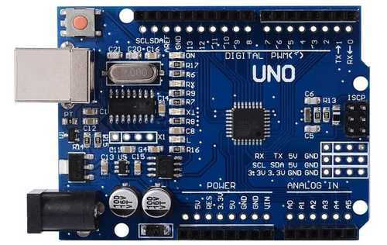 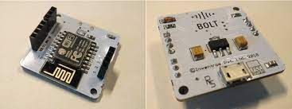

1. Fig (1) Arduino uno Fig(2) Bolt-IoT wifi module

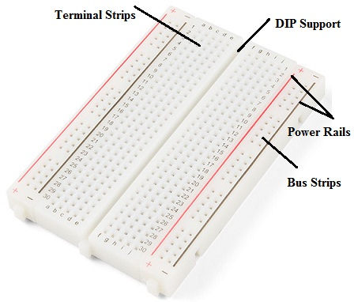 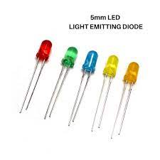 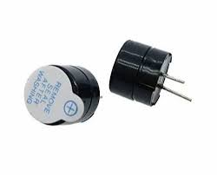

Fig(3)BreadBoard Fig(4)LED Fig(5)Buzzer

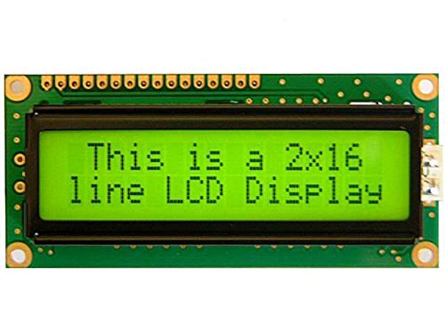 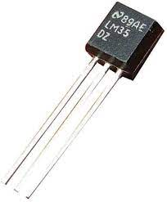 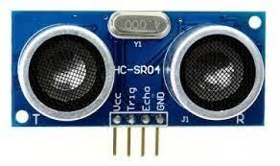

Fig(6): 16 *2 LCD Display Fig(7):LM35 Fig(8):HC-SR04

Temperature Ultrasonic Sensor

Sensor

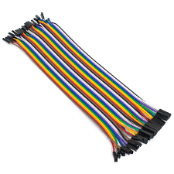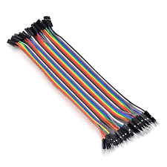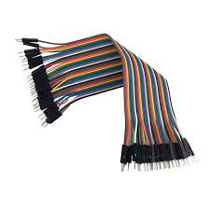

Fig(9)Female to Female Fig(10):Male to Female Fig(11):Male to Male

Jumper wires Jumper wires jumper wires

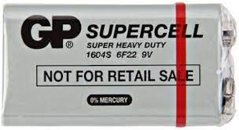 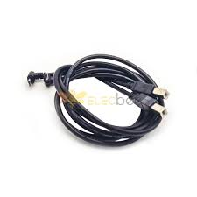

Fig(12) 9v Battery Fig(13): USB Cable type B

**SYSTEM DESIGN (BLOCK DIAGRAM):**

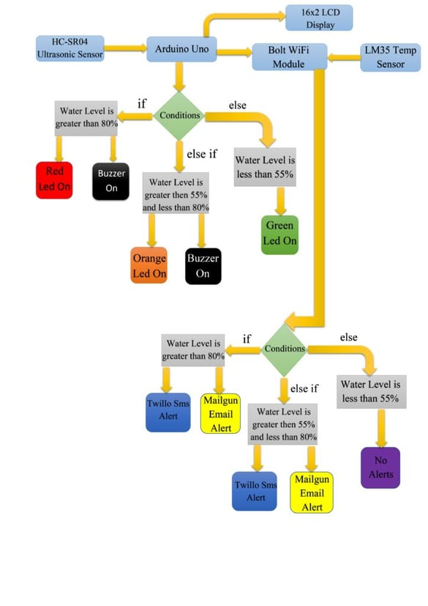**IMPLEMENTATION:**

**CIRCUIT DIAGRAM:**

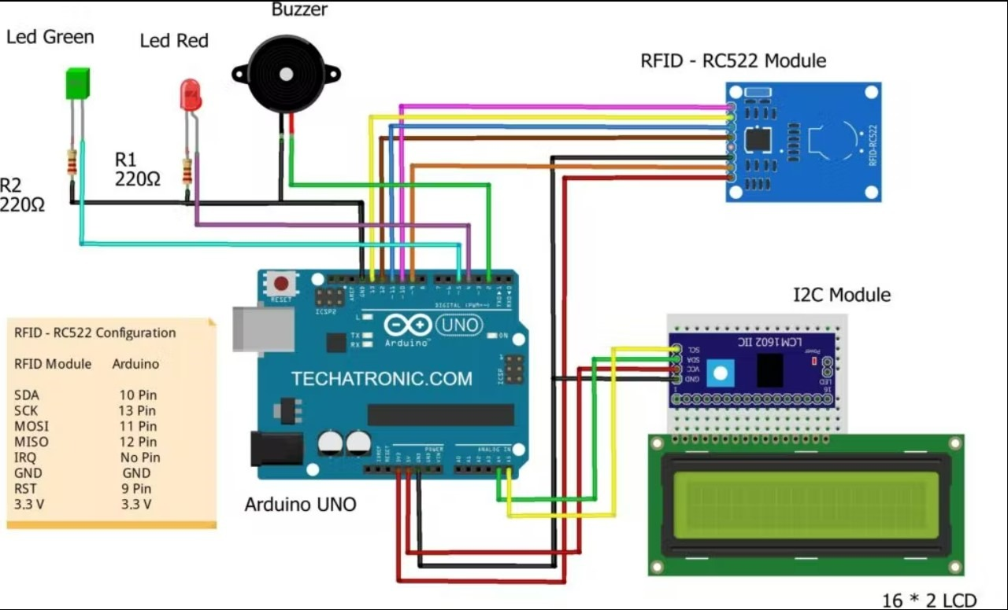

**CODE MODULES:**

#include <Ultrasonic.h>

#include <LiquidCrystal.h>

#include <DHT.h>

#include <SoftwareSerial.h>

// Define pin connections

const int trigPin = 9; // Trig pin for ultrasonic sensor

const int echoPin = 8; // Echo pin for ultrasonic sensor

const int temperaturePin = A0; // Analog pin for temperature sensor

const int buzzerPin = 13;

const int redLEDPin = 10;

const int yellowLEDPin = 12;

const int greenLEDPin = 11;

const int rxPin = 2; // RX of Bolt to TX of Arduino

const int txPin = 3; // TX of Bolt to RX of Arduino

SoftwareSerial boltSerial(rxPin, txPin);

Ultrasonic ultrasonic(trigPin, echoPin);

LiquidCrystal lcd(4, 5, 6, 7, 8, 9); // Initialize your LCD pins

DHT dht(10, DHT11); // Use DHT22 if you have one

const float waterLevelThreshold = 10.0; // Adjust this threshold

const float temperatureThreshold = 25.0; // Adjust this threshold

const float averageDistanceThreshold = 50.0; // Adjust the average distance threshold

void setup() {

lcd.begin(16, 2);

lcd.print("Flood Detector");

pinMode(buzzerPin, OUTPUT);

pinMode(redLEDPin, OUTPUT);

pinMode(yellowLEDPin, OUTPUT);

pinMode(greenLEDPin, OUTPUT);

boltSerial.begin(9600);

Serial.begin(9600);

}

void loop() {

float distance = ultrasonic.read();

float temperature = readTemperature();

lcd.clear();

lcd.setCursor(0, 0);

lcd.print("Distance: ");

lcd.print(distance);

lcd.setCursor(0, 1);

lcd.print("Temp: ");

lcd.print(temperature);

if (distance < waterLevelThreshold && temperature < temperatureThreshold) {

activateAlarm();

} else if (distance < averageDistanceThreshold) {

blinkYellowLED();

} else {

turnOffAlarm();

}

delay(1000); // Adjust the delay as needed

Serial.print("Distance: ");

Serial.println(distance);

Serial.print("Temp: ");

Serial.println(temperature);

// Send data to Bolt IoT WiFi Module

boltSerial.print("AT+CIPSTART=\"TCP\",\"");

boltSerial.print("cloud.boltiot.com");

boltSerial.print("\",80");

delay(5000);

boltSerial.println("AT+CIPSEND=30");

delay(5000);

boltSerial.println("GET /remote/API_KEY/SENSOR_VALUE");

delay(5000);

boltSerial.println((String)distance + "," + (String)temperature);

delay(5000);

boltSerial.println((char)26);

delay(5000);

boltSerial.println("AT+CIPCLOSE");

}

float readTemperature() {

int sensorValue = analogRead(temperaturePin);

float voltage = (sensorValue / 1023.0) * 5.0;

float temperatureC = (voltage - 0.5) * 100.0;

return temperatureC;

}

void activateAlarm() {

digitalWrite(buzzerPin, HIGH);

digitalWrite(redLEDPin, HIGH);

digitalWrite(yellowLEDPin, LOW);

digitalWrite(greenLEDPin, LOW);

}

void turnOffAlarm() {

digitalWrite(buzzerPin, LOW);

digitalWrite(redLEDPin, LOW);

digitalWrite(yellowLEDPin, LOW);

digitalWrite(greenLEDPin, HIGH);

}

void blinkYellowLED() {

digitalWrite(buzzerPin, LOW);

digitalWrite(redLEDPin, LOW);

digitalWrite(greenLEDPin, LOW);

// Blink the yellow LED

digitalWrite(yellowLEDPin, HIGH);

delay(500); // On

digitalWrite(yellowLEDPin, LOW);

delay(500); // Off

}

EXPERIMENTAL RESULTS:

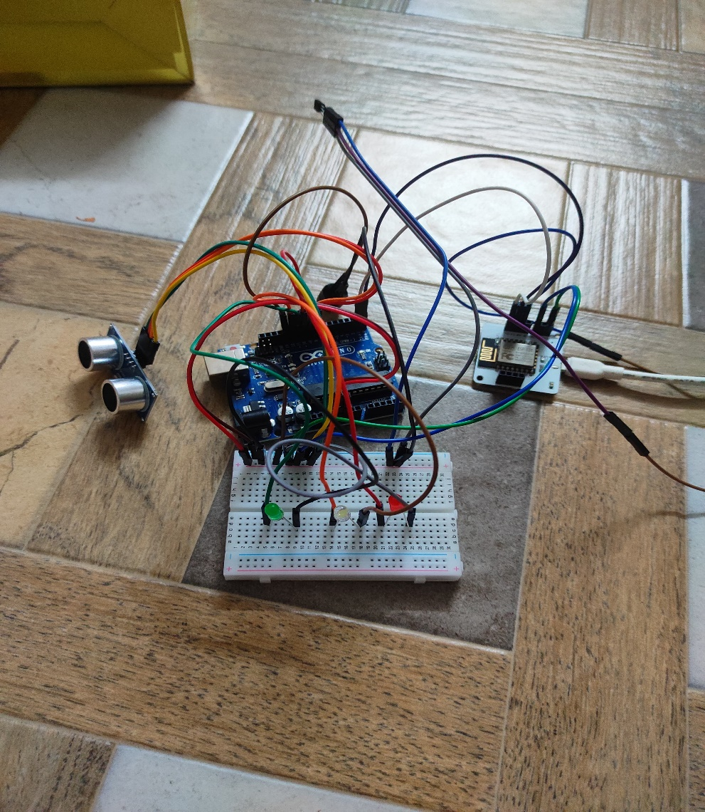

Fig(1):Real Time water level detection and reporting

Model.

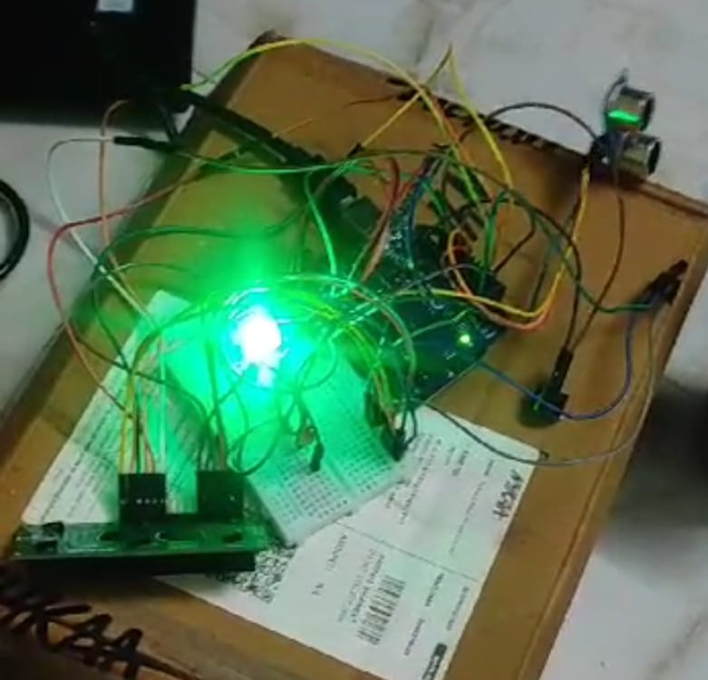

Fig(2): Testing the model of Early water level detection and reporting

**CONCLUSION AND LIMITATIONS:**

**CONCLUSION:**

In conclusion, the early water level detection and reporting project using Arduino and IoT components presents a robust solution for monitoring environmental conditions, specifically focusing on water levels and temperature. The combination of sensors, communication modules, and alert mechanisms creates a comprehensive system that can be deployed in areas prone to flooding.

In developing the system, the student had to prepare 3 major scopes of  functions which include the Arduino Uno, Bolt IoT wifi module and Temperature and Ultrasonic sensor.

The system is developed using Arduino Integrated Development Environment (IDE) software as its main platform and also Python IDLE.

**CHAPTER 6**

**RECOMMENDATIONS AND CONCLUSION**

In conclusion, the early water level detection and reporting project using Arduino and IoT components presents a robust solution for monitoring environmental conditions, specifically focusing on water levels and temperature. The combination of sensors, communication modules, and alert mechanisms creates a comprehensive system that can be deployed in areas prone to flooding. In developing the system, the student had to prepare 3 major scopes of  functions which include the Arduino Uno, Bolt IoT wifi module and Temperature and Ultrasonic sensor. The system is developed using Arduino Integrated Development Environment (IDE) software as its main platform and also Python IDLE.

There are several recommendations to be made regarding this project.

Recommendation is not meant to be used to change this project wholly, but to allow improvements in certain aspects and to put some factor into consideration. One of the recommendations for future plan is to develop the design of the prototype become smaller and lighter so that the prototype can be commercialized. On the other hand, the system is recommended to improvise in the uploading the data directly to the personal computer. A thorough research is needed to be made in order to make it successful.

**Student Self-Evaluation for the Community Service Project**

**Student Name: D.RENUKA VENKATA PADMA**

**Registration No: 22501A0540**

**Period of CSP: From: 24-07-2023 to 02-09-2023**

**Date of Evaluation:**

**Please rate your performance in the following areas:**

**Rating Scale: Letter grade of CGPA calculation to be provided.**

|  |  |  |  |  |  |  |
| --- | --- | --- | --- | --- | --- | --- |
| 1 | Oral communication | 1 | 2 | 3 | 4 | 5 |
| 2 | Written communication | 1 | 2 | 3 | 4 | 5 |
| 3 | Proactiveness | 1 | 2 | 3 | 4 | 5 |
| 4 | Interaction ability with community | 1 | 2 | 3 | 4 | 5 |
| 5 | Positive Attitude | 1 | 2 | 3 | 4 | 5 |
| 6 | Self-confidence | 1 | 2 | 3 | 4 | 5 |
| 7 | Ability to learn | 1 | 2 | 3 | 4 | 5 |
| 8 | Work Plan and organization | 1 | 2 | 3 | 4 | 5 |
| 9 | Professionalism | 1 | 2 | 3 | 4 | 5 |
| 10 | Creativity | 1 | 2 | 3 | 4 | 5 |
| 11 | Quality of work done | 1 | 2 | 3 | 4 | 5 |
| 12 | Time Management | 1 | 2 | 3 | 4 | 5 |
| 13 | Understanding the Community | 1 | 2 | 3 | 4 | 5 |
| 14 | Achievement of Desired Outcomes | 1 | 2 | 3 | 4 | 5 |
| **15** | **OVERALL PERFORMANCE** | **1** | **2** | **3** | **4** | **5** |

**Date: Signature of the student** Evaluation by the Person in-charge in the Community

**Student Name: D.RENUKA VENKATA PADMA**

**Registration No: 22501A0540**

**Period of CSP: from 24/07/2023 to 02/09/2023**

**Date of Evaluation:**

**Name of the Person in-charge: Mr.A.Prashant**

**Address with mobile number: 8019709941**

Please rate the student’s performance in the following areas:

Please note that your evaluation shall be done independent of the student’s self- evaluation.

|  |  |  |  |  |  |  |
| --- | --- | --- | --- | --- | --- | --- |
| 1 | Oral communication | 1 | 2 | 3 | 4 | 5 |
| 2 | Written communication | 1 | 2 | 3 | 4 | 5 |
| 3 | Proactiveness | 1 | 2 | 3 | 4 | 5 |
| 4 | Interaction ability with community | 1 | 2 | 3 | 4 | 5 |
| 5 | Positive Attitude | 1 | 2 | 3 | 4 | 5 |
| 6 | Self-confidence | 1 | 2 | 3 | 4 | 5 |
| 7 | Ability to learn | 1 | 2 | 3 | 4 | 5 |
| 8 | Work Plan and organization | 1 | 2 | 3 | 4 | 5 |
| 9 | Professionalism | 1 | 2 | 3 | 4 | 5 |
| 10 | Creativity | 1 | 2 | 3 | 4 | 5 |
| 11 | Quality of work done | 1 | 2 | 3 | 4 | 5 |
| 12 | Time Management | 1 | 2 | 3 | 4 | 5 |
| 13 | Understanding the Community | 1 | 2 | 3 | 4 | 5 |
| 14 | Achievement of Desired Outcomes | 1 | 2 | 3 | 4 | 5 |
| **15** | **OVERALL PERFORMANCE** | **1** | **2** | **3** | **4** | **5** |

**Date: Signature of the Supervisor**

**PHOTO GALLERY**

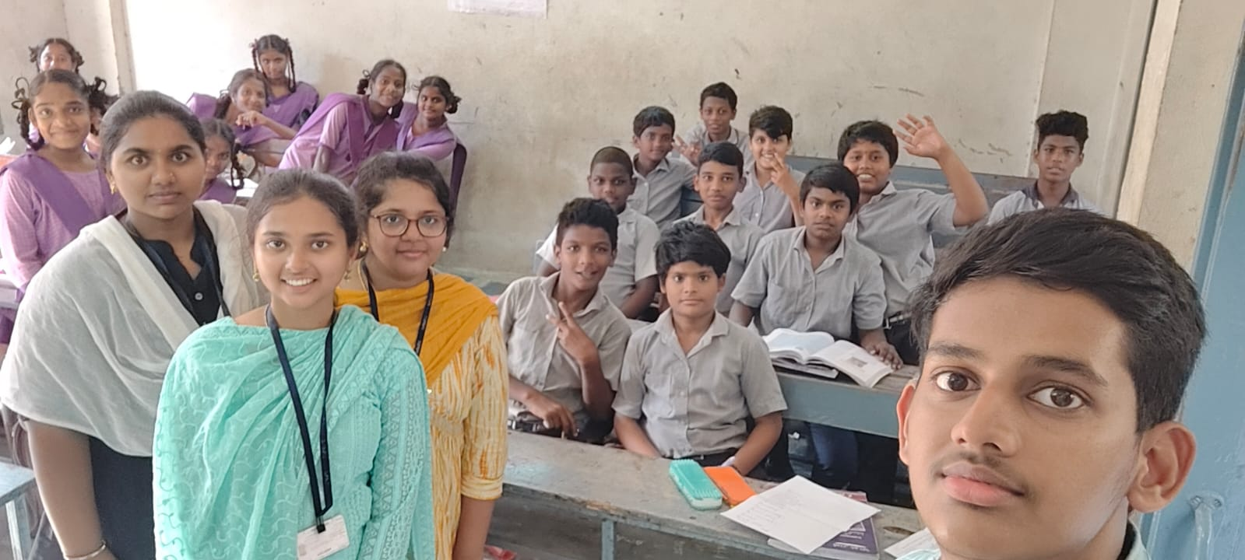

Fig(1):Discussed about the societal problems

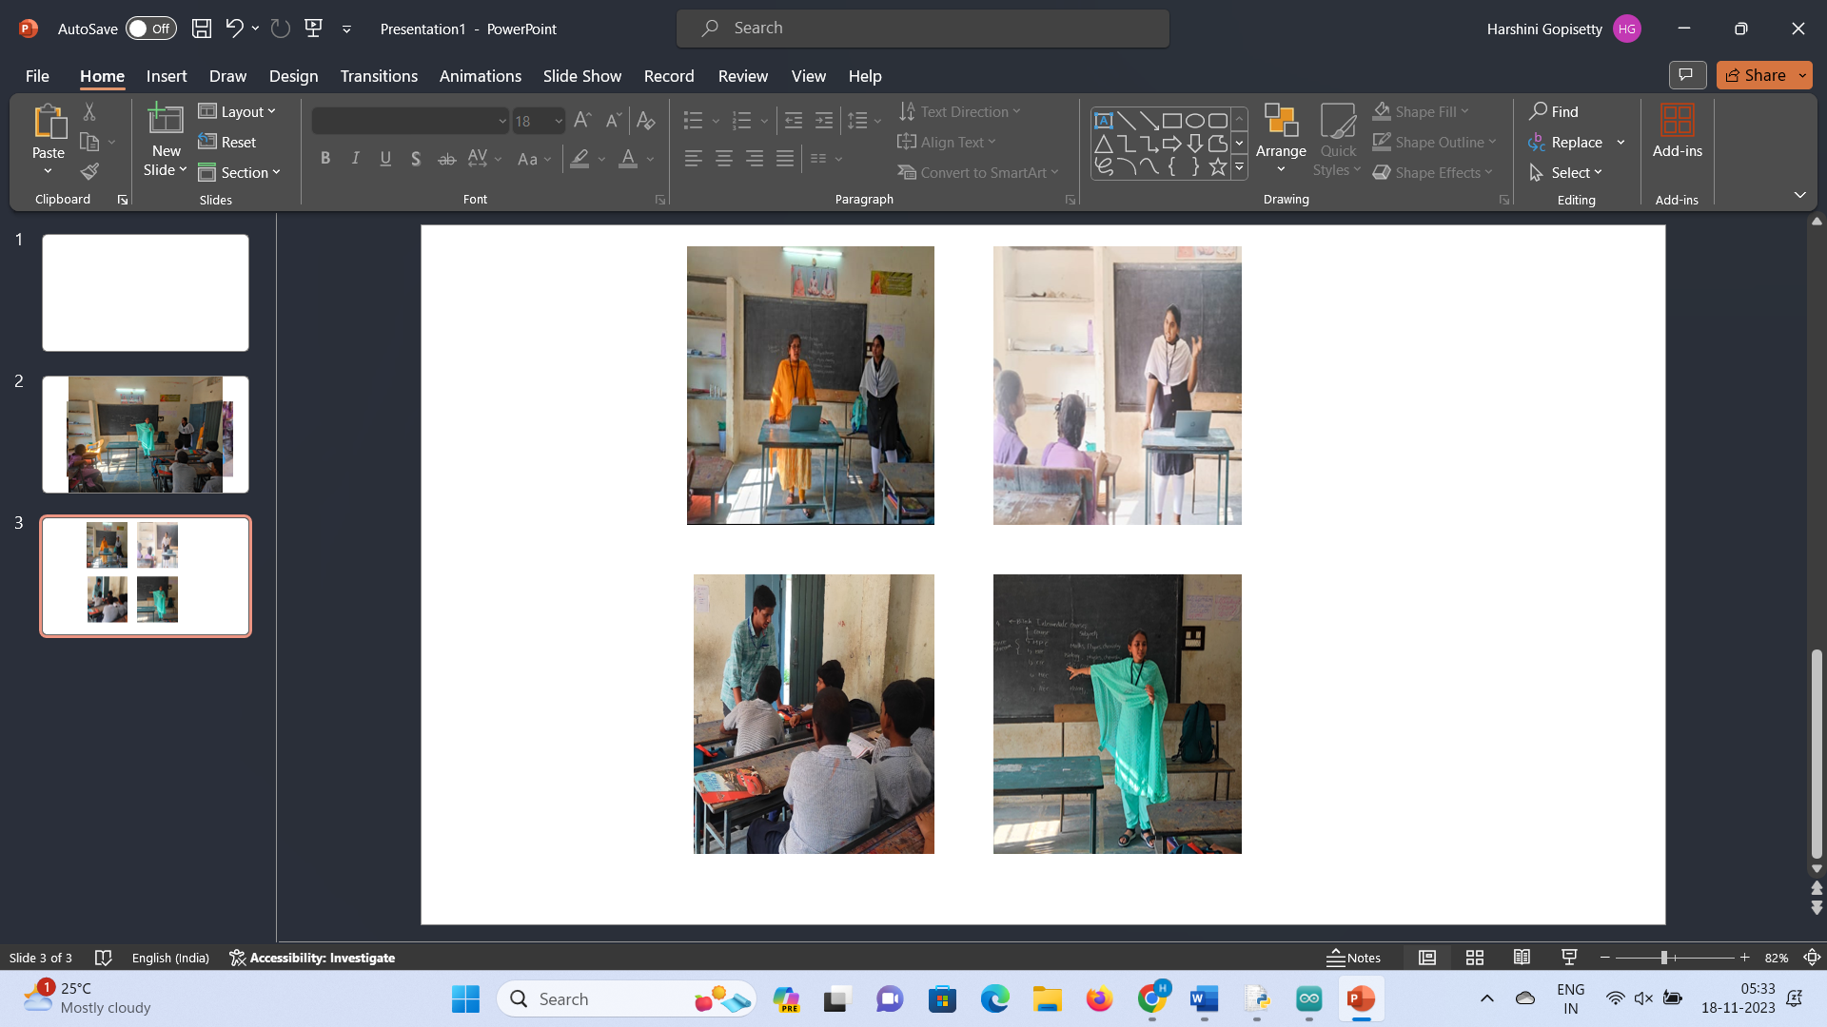

Fig(2):myself and my team members are explaining about the preventive measures to take at the time of floods .

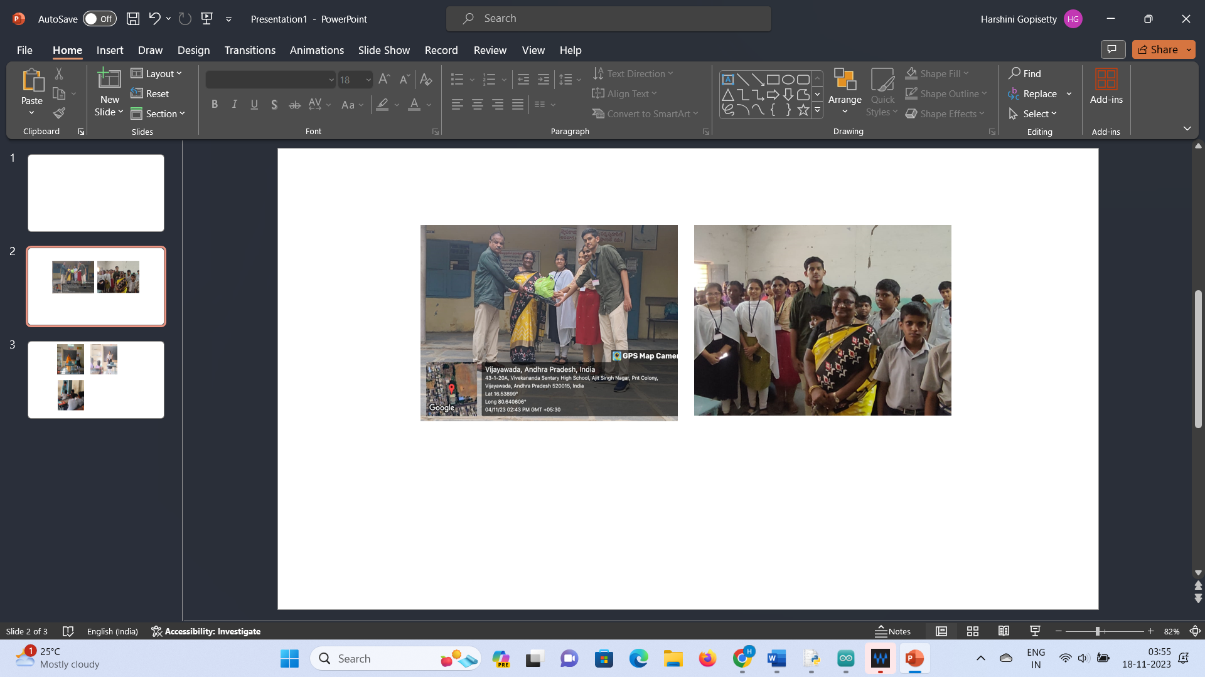

Fig(3):Students and teachers actively participated in our survey

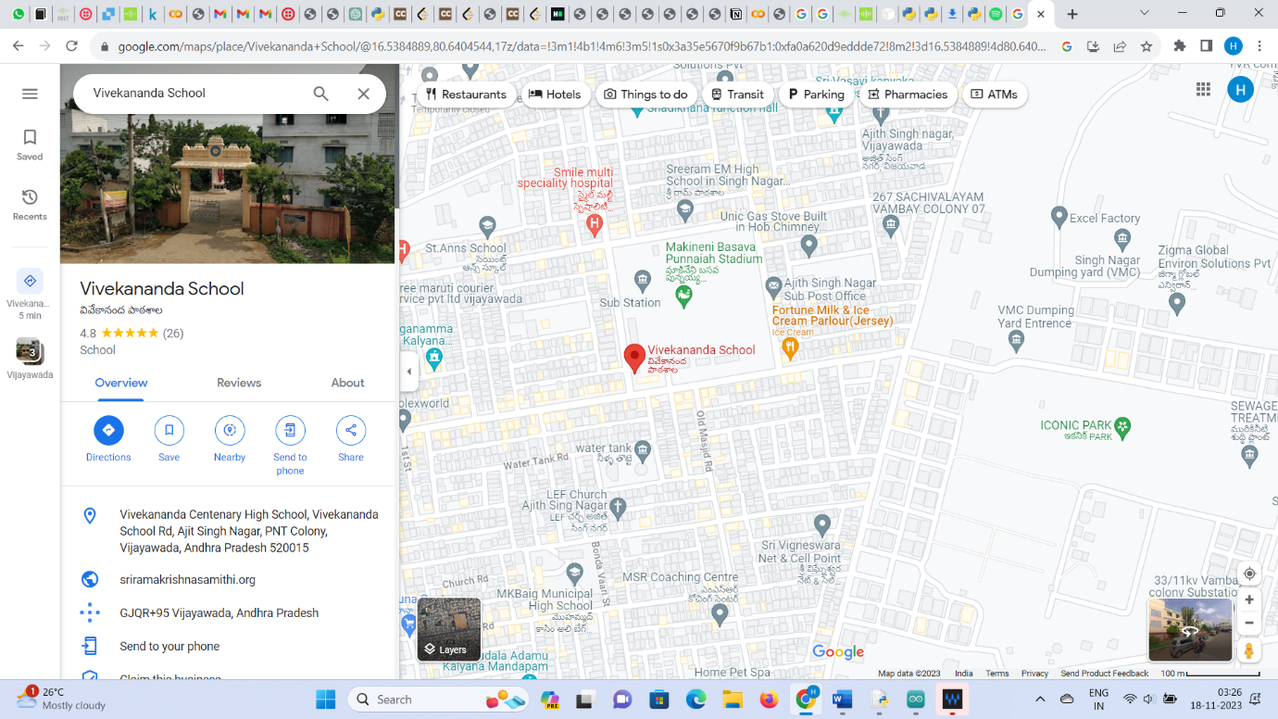

Fig(4):Location of the Government School

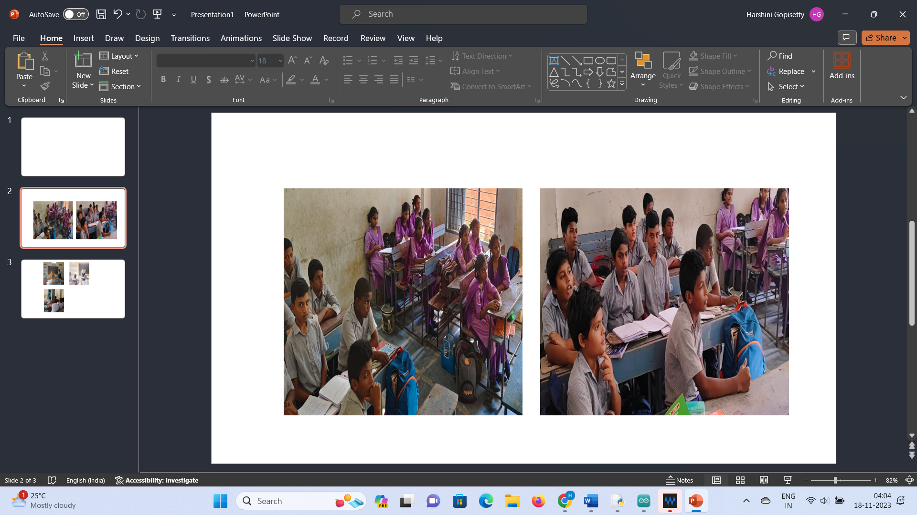

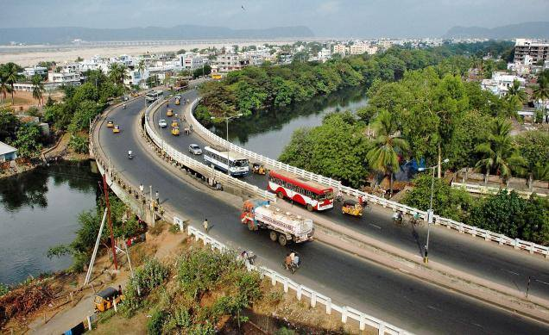

Fig(5):Krishna Lanka Skew Bridge

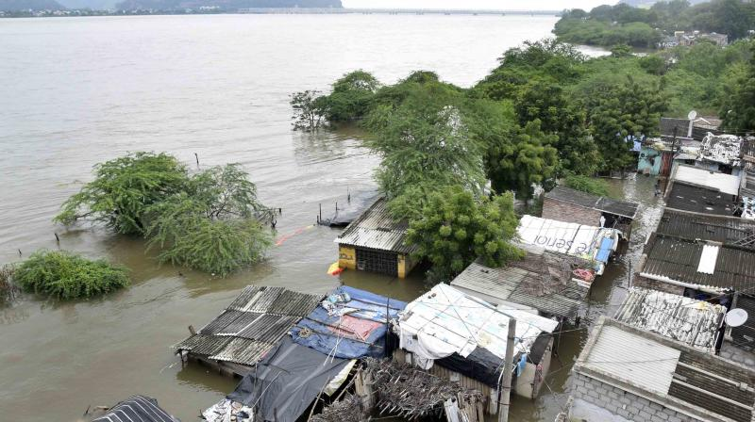

Fig(6):Kishna Lanka at the time of heavy rainfall and floods